Topic: Confusion over importance of Tube Diameter in Fireworks Hazard Rating
Sept 24th, 2020 By: Dominator Fireworks
The Liuyang Fireworks industry recognizes that leaders in Huanan Customs face a legal documentation problem where Beijing General Customs have made it very difficult for the Hunan Leaders to meet the needs of the Fireworks Industry and the legal requirements of General Customs of Beijing.
As leaders of the fireworks industry, we understand this difficult position of Huanan Customs. We understand Hunan Customs is just trying to follow the rules. Our goal is to help Hunan customs solve this “legal issue” in the General Customs documents and more importantly to reduce the true risk of fireworks shipping and transport.
The Problem Background: General Administration of Customs Order No. 238 (出口烟花爆竹检验管理办法(2018修改)现行有效 (发文字号海关总署令第238号)
Article 5 of Order #238 be amended to read. Manufacturers of export fireworks and firecrackers shall produce and store export fireworks and firecrackers in accordance with the "United Nations Dangerous Goods Recommendation Model Regulations" and relevant laws and regulations.
The UN Default list states that all cakes >30mm are 1.3g. Therefore, Hunan Customs has recently made the change that USA cakes >30mm are 1.3g per the UN Default list and therefore no exceptions can be made. We think Hunan Customs has made this decision in error after seeing some of the large USA “fake” tubes and assuming the larger size equated to more danger or at least were not allowed to be 1.4g per the UN Model Regulations.
However, Order #238 has been used since the year 2000. In all of those years, the USA Standard for consumer fireworks (APA 87-1) has been considered to be a “higher standard” than the China Domestic laws and the UN Model Regulations. Article 7 of Order #238 allows for the import country’s standard to be used in place of China regulations, if the importing country has a “higher standard”.
We will explain below in Appendix A & B that USA consumer cakes are in fact very safe (never a history of an explosion or injury in storage or transport – Appendix A) and we will explain what are the technical differences between the USA Regulations for consumer cakes and the UN Model Regulations and why the USA regulations are in fact “more strict”. – Appendix B.
Summary: Tube Diameter is not the most important factor for determining risk. Hunan Customs must evaluate burst charge and packing density as higher risk factors then Tube Diameter.
Problem Immediate Solution:
- We note that the Problem is not an actual safety issue. In the past 20 years there has not been serious storage or transportation accident involving USA Consumer cakes. Therefore, we feel this is more of a legal documentation issue as opposed to a true safety issue. Evidence of this is presented in Appendix A.
- Order #238, Article 7 states that the UN Model Regulations or the Importing Country’s Standard can be used if the Import Country has a “Higher Standard”. Appendix B will provide evidence that the USA’s standard is in fact a “Higher Standard” (or equivalent) to the UN Model Regulations for Consumer Fireworks.
Long term Solution:
- Because this is Legal Documentation issue, we believe the long term way to resolve this issue is to modify Order #238 (as was done in 2018). 海关总署令《海关总署关于修改部分规章的决定》修
- We suggest that Article 5 of Order #238 be amended to read. Manufacturers of export fireworks and firecrackers shall produce and store export fireworks and firecrackers in accordance with the relevant laws. For export to the USA product should be built according to the Department of Transportation's Hazardous Materials Regulations in Title 49, CFR and for USA consumer fireworks with the regulations of the U.S. Consumer Product Safety Commission (CPSC) published in Title 16, CFR. For export to other countries, follow the "United Nations Dangerous Goods Recommendation Model Regulations" and relevant laws and regulations.
Appendix A:
This section contains proof that USA Consumer Fireworks cakes are very safe and have never caused any explosion or injury in storage or transportation.
Every year several Consumer Fireworks retail or warehouse storage locations are involved in an “ignition”. The results have always been a limited fire with no explosion and no injury caused by the fireworks themselves. Most of these fires are caused by arson where people set the fires out of mischief or curiosity. In some instances it is suspected that the fires were set intentionally as an attempt to collect fire insurance money.
We have done a very fast internet search and identified three examples. There are many more examples for anyone willing to search:
Example #1 - July 4th, 2019 5:45 a.m. Arson suspected in fireworks storage containers near Davey Jones Fireworks, FORT MILL, S.C.
Fire only, no explosion. No one hurt. Cars can be seen driving very near the fire.
https://www.wsoctv.com/news/local/massive-fire-breaks-out-at-fireworks-stand-in-fort-mill/963857892/

Example #2 – Sept. 24, 2018, Stateline Fireworks - Winchester, NH. – Fire started by gunshot. 75 year old man arrested. Fire only, no injury.
https://www.unionleader.com/news/crime/suspect-in-fire-at-winchester-fireworks-store-is-headed-to-court/article_98d253bc-532f-5412-bad5-e2574050a55a.html

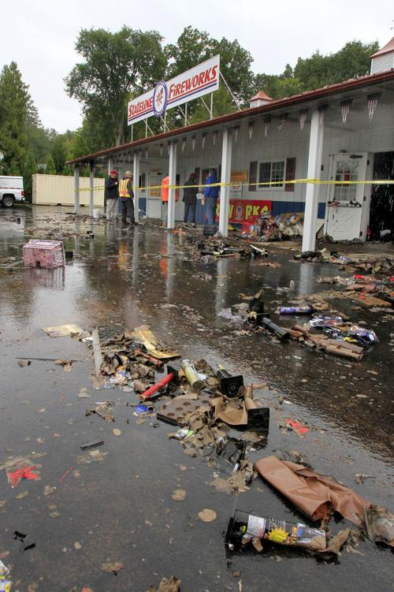

Example #3 - July 6, 2014 Gannett, TN. Fire only, no explosion. No injury. Cars seen driving close to the fire.
https://www.tennessean.com/story/news/local/2014/07/06/east-tennessee-fireworks-engulfed-in-flames/12272149/

Examples of deadly fireworks accidents: (https://en.wikipedia.org/wiki/List_of_fireworks_accidents_and_incidents)
Here are examples of deadly international fireworks accidents and an analysis of what type of product has caused the accident. Note that ZERO deadly accidents were caused by USA Consumer Fireworks. 27 accidents were caused by Factory Explosions. This also represents China’s greatest risk for accidents. 14 accidents were caused by 1.3g warehouses. 10 accidents happened in nightclubs which were caused by small non-explosive fireworks that caused a fire. Finally 6 accidents happened in outdoor 1.3g displays.
Table 1: Examples of deadly fireworks accidents: (https://en.wikipedia.org/wiki/List_of_fireworks_accidents_and_incidents)
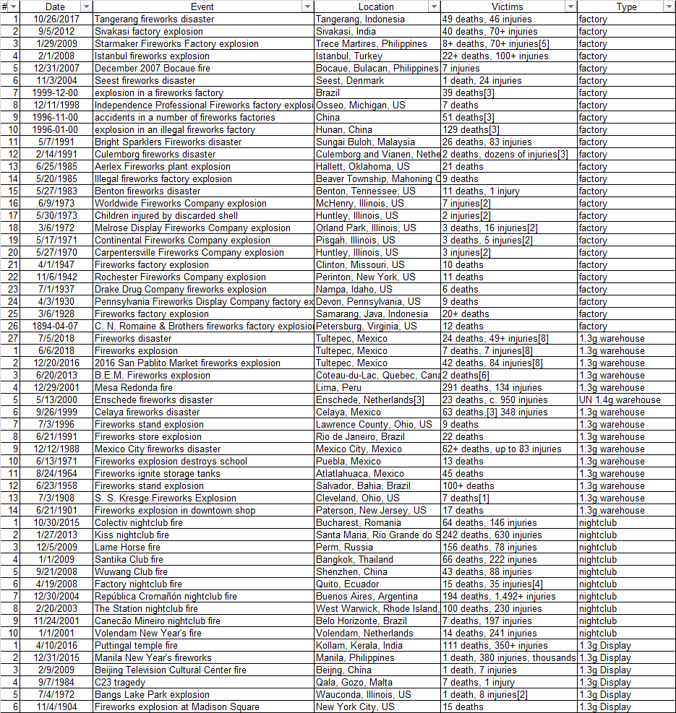

The important point of this table is that USA Consumer Fireworks have never caused a deadly accident. And therefore do not pose the risk that Hunan Customs imagines. The large USA tubes are fake and used for marketing purposes only.
The real risk for accidents center on fireworks factories where loose powder & large quantity of semi-finished goods create a mass explosion explosive danger. Many deadly accident both inside and outside of China confirm this fact. Therefore the fireworks industry needs to focus on reducing factory manufacturing risk as the first priority.
The next risk for Hunan Customs revolves around the storage and warehousing of 1.3g fireworks. Keep in mind that some United Nations 1.4g fireworks are classified as 1.3g in USA. This is due to the use of powerful flash powder for the burst charge and due to lack of spacers between tubes. So United Nations 1.4g cakes potentially pose a larger risk of causing deadly explosions that USA Consumer cakes.
Cakes with no “air gap” (USA 1.3g cakes and UN 1.4g cakes) can cause “sympathetic propagation” due to the fact that each tube is touching one another with no “air gap” in-between. This leads to one shot quickly igniting the shot next to it via shock and that leads to mass explosions. These mass explosions are what cause deaths. Deaths are not caused by cake insert shells acting as deadly projectiles. Cake inserts do not contain enough kinetic energy to pose a serious threat of death in a transportation or storage accident. Deaths are also not caused by fire unless there is a large crowd of people such as at a public display or indoor nightclub. Public Displays and Nightclubs are not the not the responsibility of Hunan Customs. Therefore, the real deadly risk for Hunan Customs is “sympathetic propagation”. Cakes following the USA regulations will not “mass explode via sympathetic propagation”. However, cakes made to the UN Model Regulations can. Therefore, the USA Standard is the “higher standard”.
Wire Cages have been used in the past, but they have been used to reduce a dense pack 1.3g cake to a 1.4g item. For example, Dutch Cakes that are clearly 1.3g (per USA standards) are shipped in wire cages to allow them to be classified as 1.4g. The purpose of the wire cage is not to stop the small 30mm shells from flying. The wire cages are intended to prevent “sympathetic propagation” and reduce the chance of a mass explosion. The Dutch are particularly aware of the risks of these powerful 1.4g UN Cakes because of the deadly Enschede fireworks disaster, where 23 people died. So Europe uses wire cages to stop “sympathetic propagation”, the wire cages are not designed to stop the small 30mm shell from flying.
Conclusion: Mass explosions via sympathetic propagation are the main risk for Hunan Customs. USA Consumer cakes do not mass explode. We have 20 years of evidence and technical analysis to prove this point. Wire Cages are used in Europe to prevent mass explosions. They are not used to stop small shells from shooting. If the goal was to stop small shells, then every cake, including 1 inch and smaller would need a wire cage. When evaluating risk of fireworks small shells should “excluded” from the evaluation. The UN Series 6c was written to classify Explosives and not fireworks. Therefore, the evaluation criteria should exclude fireworks insert shells as these small paper projectiles do not pose any true deadly risk.
Finally, fires started by fireworks at outdoor events or nightclubs are also a risk for fireworks in general, but Hunan Customs is not responsible. Local fire officials can prevent these deaths by ensuring Fire Exits are available in buildings and restricting the use of indoor fireworks unless under supervisions of professionals.

Appendix B:
This section contains technical evidence fireworks are “more strict” then the UN Model Regulations or China Regulations.
USA Regulations Reference: Department of Transportation's Hazardous Materials Regulations in Title 49, CFR and for USA consumer fireworks with the regulations of the U.S. Consumer Product Safety Commission (CPSC) published in Title 16, CFR.
https://www.americanpyro.com/assets/docs/PHMSADocs/apa stand 87-01.pdf

Table 2: Technical Criteria for 1.4g Rating USA vs UN:
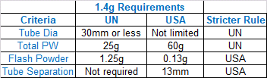
Conclusion, the UN Standard and USA Standard have different risk criteria. Hunan Customs can’t only focus on Tube Diameter as the main risk factor. A total of four risk factors must be evaluated.
Table 3 will explain the reasons that USA cakes are less dangerous then cakes made per the UN Model Regulations.

Table 3: Analysis of Risk for USA 1.4g cake vs UN 1.4g cake
For Hunan Customs, the most common storage and transportation method for Consumer Fireworks will be in a 40 foot High Cube Metal Ocean Container. These containers typically hold 68 CBM of fireworks.
Therefore, in order to evaluate risk, Hunan Customs should look at the total Powder Weight and the total Flash Powder Weight in a full container of USA cakes vs UN Cakes.
Using this evaluation it is clear to see that USA Cakes are in fact less dangerous and therefore the USA Regulations are “More Strict” then the “UN Model Regulations”. Therefore, USA Cakes >30MM should be allowed to be classified as 1.4g as has been the tradition for more than 20 years.
From this chart it is clear to see that the large USA 3 inch cakes are actually much safer for storage and transportation then the smaller, denser UN cakes. In fact, the UN cakes contain about 150 times more of the powerful “flash powder” and about 10 times more total powder then the large 3 inch USA cakes.
The reason the USA cakes have so much less powder is because they are mostly fake empty space used for marketing purposes to make them appear larger. The goal is to “market the items” as more powerful, but in fact they are less powerful then the small, dense UN cakes.
Summary: UN cakes in an ocean shipping container contain about 150 times more dangerous flash powder and 10 times more total powder.
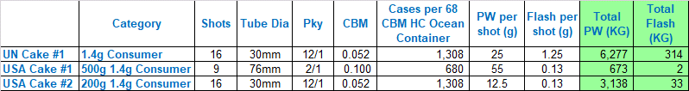
USA 3 inch 9 Shot cake vs UN 30mm 16 shot cake
The USA cake looks much larger and more dangerous, but in fact it contains much less total powder weight per CBM because it is mostly fake tubes, and empty space used to “market” the item.
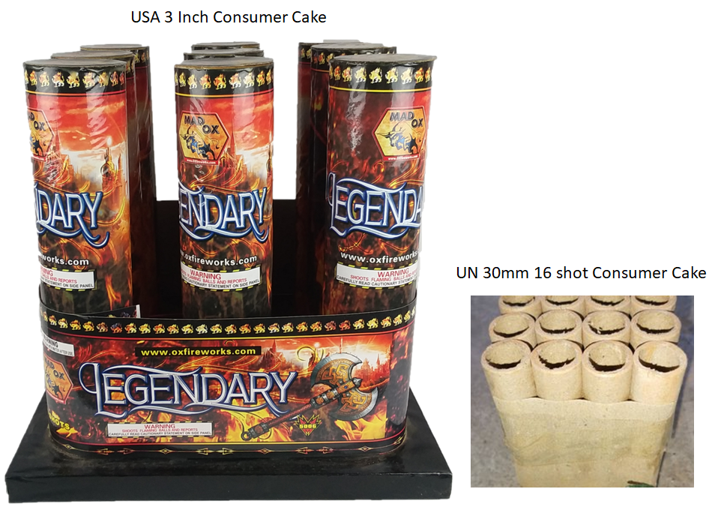

Final Conclusion:
Article 7 of the General Administration of Customs Order No. 238 出口烟花爆竹检验管理办法(2018修改)现行有效 (发文字号海关总署令第238号) States that import country laws to be used if they are “stricter” then the UN Model Regulations.
We have proven both though 20 years of examples of “No Accidents” and through Technical Analysis that the USA law is in fact stricter for consumer cakes.
The main reason that USA law is “stricter” is that it limits the very powerful “flash powder” which is about 10 times more powerful than normal Black Powder or equivalent USA Burst Charges. Also, the USA requires at least 13mm gap between each tube. This space does two things. 1.) It limits the total number of “cakes” that can be loaded into a shipping container. 2.) The empty space acts to absorb the shock from one shot to another and prevents “sympathetic propagation” which is the technical factor that leads to deadly explosions.
Conclusion: Per Article 7 of Order 238, USA Regulations are “stricter” then the UN Model Regulations, therefore Hunan Customs should allow 1.4g CIQ certificates to be issued for all USA cakes made per the USA Regulations (as has been done for the last 20 years without any storage or shipping accidents from USA consumer cakes in China or abroad).

